A PROJECT REPORT

ON

CUSTOMER RELATIONSHIP MANAGEMENT WEB APP

Submitted by

Kajol Sisodiya

Simran Jain

**Table of Content**

1. Introduction

1.1 Purpose of this project

1.2 Objective

1.3 Scope

1.4 Intended Audience

1.5 Business Case

2. Technology Used

2.1 AngularJS

2.2 HTML

2.3 Bootstrap

2.4 JSON

2.5 JavaScript

2.6 CSS

3. Methodologies Used

3.3.1 SCRUM

4. Hardware and Software Requirements

4.1 Hardware

4.2 Software

5. Product Scope

6. Definition

7. E-R Diagram

8. Use Case Diagram

9. Snapshots

**1. Introduction**

**1.1 Purpose of this Project**

CRM software is for telecommunication company. CRM software records customer contact information such as email, telephone, website social media profile, history of bills and more. It can also automatically pull in other information, such as recent news about the customer’s activity, and it can store details such as a client's personal preferences on communications.

CRM gives you information about invoices and order number of customers. Orders are filtered according to date and are shown in particular timeline. Support team can filter orders according to date or order numbers.

The CRM system organizes this information to give you a complete record of individuals and companies, so you can better understand your relationship over time.

CRM software improves customer relationship management by creating a 360° view of the customer, capturing their interactions with the business, and by surfacing the information needed to have better conversations with customers. CRM enables a business to deepen its relationships with customers, service users, colleagues, partners and suppliers. Forging good relationships and keeping track of prospects and customers is crucial for customer acquisition and retention, which is at the heart of a CRM’s function. You can see everything in one place — a simple, customizable dashboard that can tell you a customer’s previous history with you, the status of their orders, any outstanding customer service issues, and more.

The benefits of CRM are

1. Enhanced contact management  
2. Cross-team collaboration  
3. Heightened productivity  
4. Empowered sales management  
5. Accurate sales forecasting  
6. Reliable reporting  
7. Improved sales metrics  
8. Increased customer satisfaction and retention  
9. Boosted marketing ROI  
10. Enriched products and services

Purpose of CRM on Practice

* Guiding any kind of interplay and/or cooperation with clients;
* Acquiring new clients;
* Servicing current client base;
* Keeping clients;
* Identification of high-rated clients against the low-rated ones;
* Information update along with technical assistance on web resources 24/7;
* Following an individual approach to each client;
* Providing an effective mechanism to guide and schedule follow-up sales;
* Tracking all contact points between a company and a client;
* Identifying possible problems at early stages;
* Providing an effective mechanism to deal with client complaints;
* Tracking individual preferences through Internet activity;
* Personalizing product offerings to each client.

**1.2 Objective**

The major objective of this project is to ease customer details view for support team who are going to contact customers. It is intended to give 360 degree view of customer details.

Below are the objectives that shall be fulfilled post the execution of this project:

* Customer’s history 360 degree view.
* Requests for service by customer.
* Accepting requests made by customer and providing service.
* Customer timeline
* Order and Invoice Details
* Filter Details of customers

**1.3 Scope**

This sub-section shall state the scope of this detailed design document

* Create and maintain customer information.

**1.4 Intended Audience**

The intended audience for this document are

* Developers, testers, other associates in the project
* Technical lead, Scrum Master
* Product Owner
* Support Team

**1.5 Business Case**

With the rapid increase of customers in telecommunication companies a 360 degree view of customer’s history is very important to support team. While the importance of CRM has traditionally been as a sales and marketing tool, some of the biggest gains can come in other areas, such as customer services , HR, supply-chain and partner management.

**2. Technologies Used**

**2.1 AngularJS**

AngularJS is a structural framework for dynamic web apps. It lets you use HTML as your template language and lets you extend HTML's syntax to express your application's components clearly and succinctly. AngularJS's data binding and dependency injection eliminate much of the code you would otherwise have to write. And it all happens within the browser, making it an ideal partner with any server technology.

AngularJS is what HTML would have been, had it been designed for applications. HTML is a great declarative language for static documents. It does not contain much in the way of creating applications, and as a result building web applications is an exercise in what do I have to do to trick the browser into doing what I want?

The impedance mismatch between dynamic applications and static documents is often solved with:

* **a library** - a collection of functions which are useful when writing web apps. Your code is in charge and it calls into the library when it sees fit. E.g., jQuery.
* **frameworks** - a particular implementation of a web application, where your code fills in the details. The framework is in charge and it calls into your code when it needs something app specific. E.g., durandal, ember, etc.

AngularJS takes another approach. It attempts to minimize the impedance mismatch between document centric HTML and what an application needs by creating new HTML constructs. AngularJS teaches the browser new syntax through a construct we call directives. Examples include:

* Data binding, as in {{}}.
* DOM control structures for repeating, showing and hiding DOM fragments.
* Support for forms and form validation.
* Attaching new behavior to DOM elements, such as DOM event handling.
* Grouping of HTML into reusable components.

**2.2 HTML**

HTML is a computer language devised to allow website creation. These websites can then be viewed by anyone else connected to the Internet. It is relatively **easy to learn**, with the basics being accessible to most people in one sitting; and quite **powerful** in what it allows you to create. It is constantly undergoing revision and evolution to meet the demands and requirements of the growing Internet audience under the direction of the, the organization charged with designing and maintaining the language.

The definition of HTML is **Hypertext Markup Language**.

* Hypertex*t* is the method by which you move around on the web — by clicking on special text called **hyperlinks** which bring you to the next page. The fact that it is *hyper* just means it is not linear — i.e. you can go to any place on the Internet whenever you want by clicking on links — there is no set order to do things in.
* Markup is what **HTML tags** do to the text inside them. They mark it as a certain type of text (italicised text, for example).
* HTML is a *Language*, as it has code-words and syntax like any other language.

**2.3 Bootstrap**

* Bootstrap is the most popular HTML, CSS and JavaScript framework for developing a responsive and mobile friendly website.
* It is absolutely free to download and use.
* It is a front-end framework used for easier and faster web development.
* It includes HTML and CSS based design templates for typography, forms, buttons, tables, navigation, modals, image carousels and many others.
* It can also use JavaScript plug-ins.
* It facilitates you to create responsive designs.

**2.4 JSON**

JSON is an open standard for exchanging data on the web. It supports data structures like object and array. So it is easy to write and read data from JSON.

What is JSON

* JSON stands for JavaScript Object Notation.
* JSON is an open standard data-interchange format.
* JSON is lightweight and self describing.
* JSON is originated from JavaScript.
* JSON is easy to read and write.
* JSON is language independent.
* JSON supports data structures such as array and objects.

**2.5 JavaScript**

JavaScript is a dynamic computer programming language. It is lightweight and most commonly used as a part of web pages, whose implementations allow client-side script to interact with the user and make dynamic pages. It is an interpreted programming language with object-oriented capabilities.

JavaScript was first known as **LiveScript,** but Netscape changed its name to JavaScript, possibly because of the excitement being generated by Java. JavaScript made its first appearance in Netscape 2.0 in 1995 with the name **LiveScript**. The general-purpose core of the language has been embedded in Netscape, Internet Explorer, and other web browsers.

The [ECMA-262 Specification](http://www.ecma-international.org/publications/index.html) defined a standard version of the core JavaScript language.

* JavaScript is a lightweight, interpreted programming language.
* Designed for creating network-centric applications.
* Complementary to and integrated with Java.
* Complementary to and integrated with HTML.
* Open and cross-platform

**2.6 CSS**

**C**ascading **S**tyle **S**heets, fondly referred to as CSS, is a simple design language intended to simplify the process of making web pages presentable.

CSS handles the look and feel part of a web page. Using CSS, you can control the color of the text, the style of fonts, the spacing between paragraphs, how columns are sized and laid out, what background images or colors are used, layout designs,variations in display for different devices and screen sizes as well as a variety of other effects.

CSS is easy to learn and understand but it provides powerful control over the presentation of an HTML document. Most commonly, CSS is combined with the markup languages HTML or XHTML.

Advantages of CSS

* **CSS saves time** − You can write CSS once and then reuse same sheet in multiple HTML pages. You can define a style for each HTML element and apply it to as many Web pages as you want.
* **Pages load faster** − If you are using CSS, you do not need to write HTML tag attributes every time. Just write one CSS rule of a tag and apply it to all the occurrences of that tag. So less code means faster download times.
* **Easy maintenance** − To make a global change, simply change the style, and all elements in all the web pages will be updated automatically.
* **Superior styles to HTML** − CSS has a much wider array of attributes than HTML, so you can give a far better look to your HTML page in comparison to HTML attributes.
* **Multiple Device Compatibility** − Style sheets allow content to be optimized for more than one type of device. By using the same HTML document, different versions of a website can be presented for handheld devices such as PDAs and cell phones or for printing.

**3. Methodologies Used**

**3.3.1 SCRUM**

Scrum is a framework within which people can address complex adaptive problems, while productively and creatively delivering products of the highest possible value.

Scrum itself is a simple framework for effective team collaboration on complex products.  Scrum co-creators Ken Schwaber and Jeff Sutherland have written [The Scrum Guide](http://www.scrumguides.org/) to explain Scrum clearly and succinctly.  This Guide contains the definition of Scrum. This definition consists of Scrum’s roles, events, artifacts, and the rules that bind them together.

Scrum is:

* Lightweight
* Simple to understand
* Difficult to master

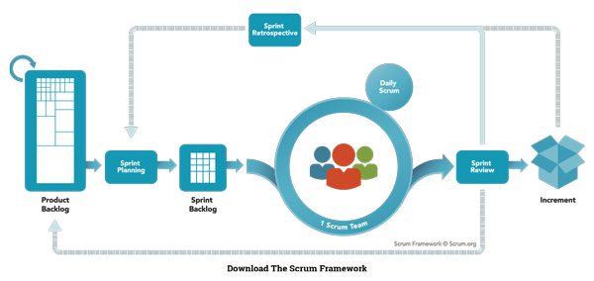

Scrum has three roles: Product Owner, Scrum Master, and Team.

**Product Owner:** The Product Owner should be a person with vision, authority, and availability. The Product Owner is responsible for continuously communicating the vision and priorities to the development team.It’s sometimes hard for Product Owners to strike the right balance of involvement. Because Scrum values self-organization among teams, a Product Owner must fight the urge to micro-manage. At the same time, Product Owners must be available to answer questions from the team.

**Scrum Master:** The Scrum Master acts as a facilitator for the Product Owner and the team. The Scrum Master does not manage the team. The Scrum Master works to remove any impediments that are obstructing the team from achieving its sprint goals. This helps the team remain creative and productive while making sure its successes are visible to the Product Owner. The Scrum Master also works to advise the Product Owner about how to maximize ROI for the team.

**Team:** According to Scrum’s founder, “the team is utterly self managing.” The development team is responsible for self organizing to complete work. A Scrum development team contains about seven fully dedicated members (officially 3-9), ideally in one team room protected from outside distractions. For software projects, a typical team includes a mix of software engineers, architects, programmers, analysts, QA experts, testers, and UI designers. Each sprint, the team is responsible for determining how it will accomplish the work to be completed. The team has autonomy and responsibility to meet the goals of the sprint.

**4. Hardware and Software Requirements**

**4.1 Hardware**

Desktop PC with 8GB RAM

**4.2 Software**

Angular 5.0

Visual Studio Code 1.30

**5. Product Scope**

This product is a powerful web application for 360 degree view of customer’s history. CRM or customer relationship management, is concerned with the development and maintenance of mutually beneficial relationships with strategically significant partners. Its focus is the creation of long-term value, and not just short-term profits, for the company and all it works with. The scope of CRM can thus be defined according to its constituencies, how long-term value can be created for and with them and the benefits of doing so.

## The Customer

The customer is of key importance because only relationships with customers generate revenues for a company. Establishing a good long-term relationship with customers can take the form of the provision of benefits such as special prices and preferential treatment. Doing so can bring about drastic increases in value due to frequent sales from satisfied customers, positive word of mouth, a reduced need for product sampling and advertising, and increased possibility of cross-selling or purchasing of other products.

## The Suppliers

Suppliers provide input, such as raw materials, technologies, components, investment, human resources and expertise, to the company’s value chain. In 2010 companies have tended to shift to a smaller number of suppliers and create and maintain long-term relationships with them. Enhanced performance can result from improved communication and coordination with this set of suppliers. Purchasing costs can be reduced thanks to elimination of the need to constantly seek cheaper sources. With fewer vendors, increased cooperation between the remaining parties in the form of management-information system alignment and customer-information sharing becomes possible.

**6. Definition**

* Client: Cognizant Client who is using our software.
* Customer: Cognizant Client’s end-customers. The companies that actually make Payments to Clients.
* Mechanic: They are project used words who will provide service to the customer.
* Invoice: A receipt of acknowledgement for the goods or services provided and their respective cost. Customer receives an invoice from the mechanic specifying the goods dispatched or soled and the cost associated with the purchase.
* Location Based: The customer will search for the mechanic on the closest vicinity.
* Rating: The customer will give the rating to the mechanic on the basis of the service provided by the mechanic.
* Notification: The customer will receive a notification on the basis of the mechanic acceptation or rejection.
* Payment: Money paid by Customer to Mechanic for some product or service they bought and got billed for. Payment can be in the form of: Checks, Cash or Credit or Debit Card transactions.

**7. E-R Diagram**

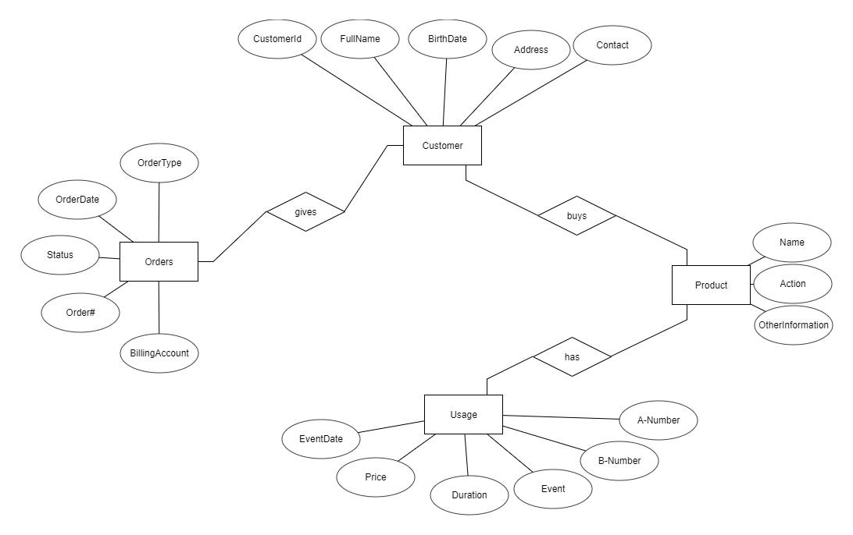

**8. Use Case Diagram**

Create Customer Relationship

Check Requests or Raise Requests

Manage Products

Manage Offerings

Add Comments

Manage User and Full Application

Manage Customer Feedback

**Use Case Diagram of CRM Application System**

Company

Customer

**8. Snapshots**

